Lab#2

Database System

Submitted by: Adil Khan
Roll No. : 2330-0030

Submitted to:
Mam Yusra Tahir

Task no 1:
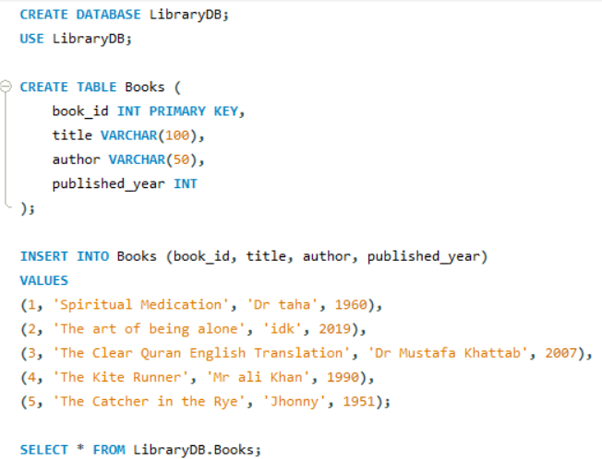

Output:
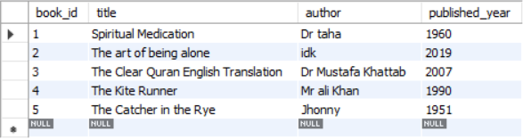

Task no 2:
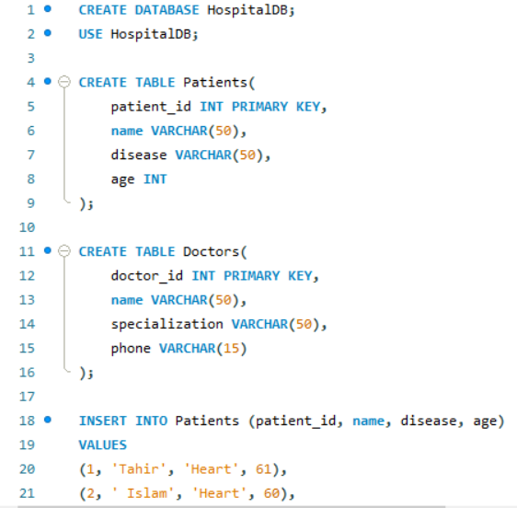

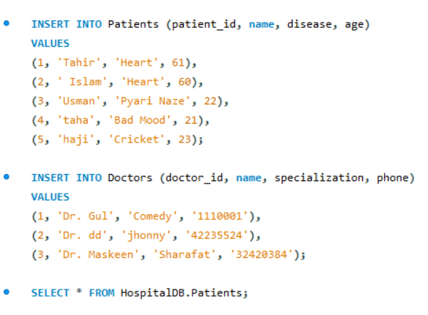
output
